**Largest Innovative Community**

Explore Innovative community around the world

**Why Innovasol**

**The Biggest Innovative Community in the globe**

**A creative Platform**

Just do it

E

xamine Developing innovative community economy

mploy Most talented professionals from design community

ntitle with the Innovative community

**Animation**





<http://www.legworkstudio.com/animation/allstate-survival-guide>



http://www.legworkstudio.com/animation/nissan-zero-gravity



<http://www.legworkstudio.com/animation/bc4u-what-if>



<http://www.legworkstudio.com/animation/climate-reality-pledge/>

**Graphic Design**





<http://www.ninesixty.co.uk/work/go-see-this>



<http://chulakov.com/work/summer-with-barni#3>

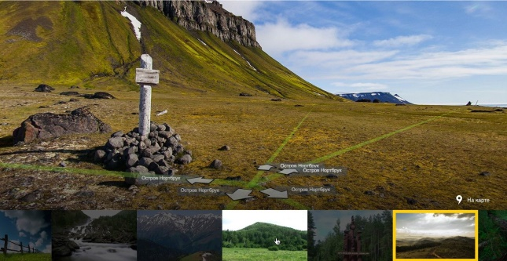

<http://chulakov.com/work/yandex#zapovedniki>



<http://chulakov.com/work/ikea-service#3>

**Mobile Development**





<http://www.ninesixty.co.uk/work/integrated-change>



<http://chulakov.com/work/tanuki-app#4>



<http://chulakov.com/work/tele2-mobile-dating>



<http://chulakov.com/work/ris-app>

**Web Development**





<http://www.ninesixty.co.uk/work/laced>



<http://www.ninesixty.co.uk/work/asylum>

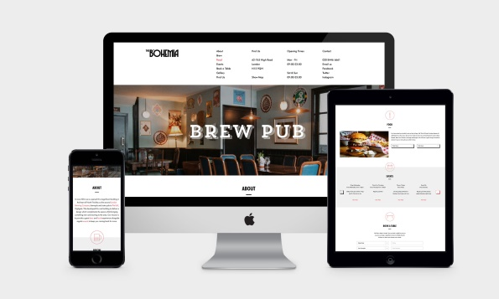

<http://www.ninesixty.co.uk/work/the-bohemia>



<http://www.ninesixty.co.uk/work/lazerian>